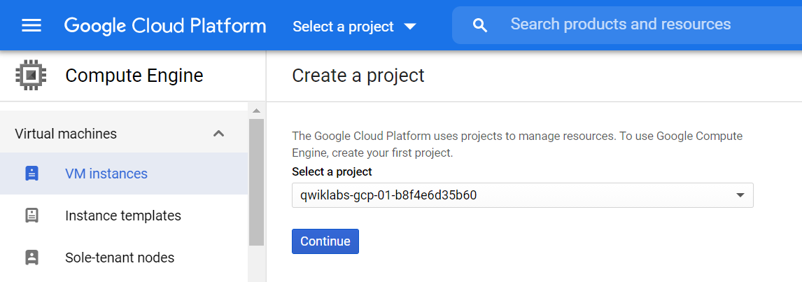

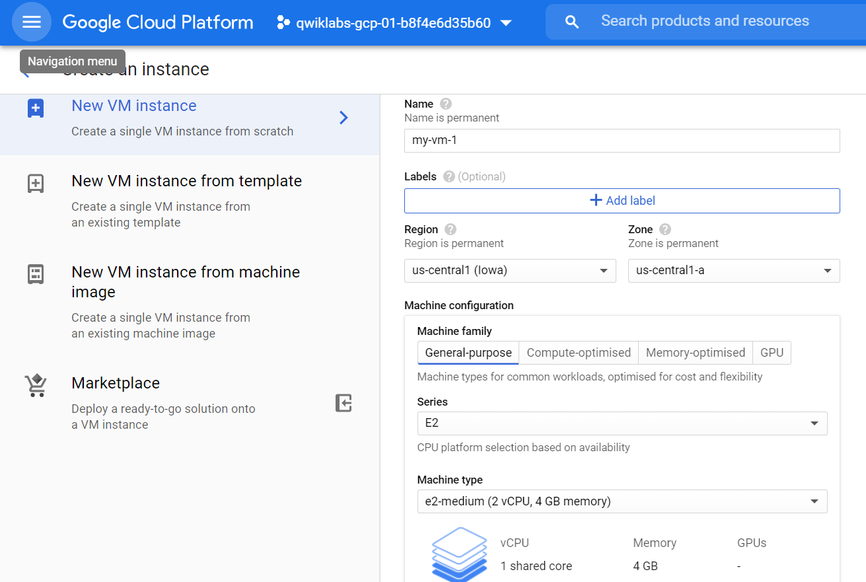

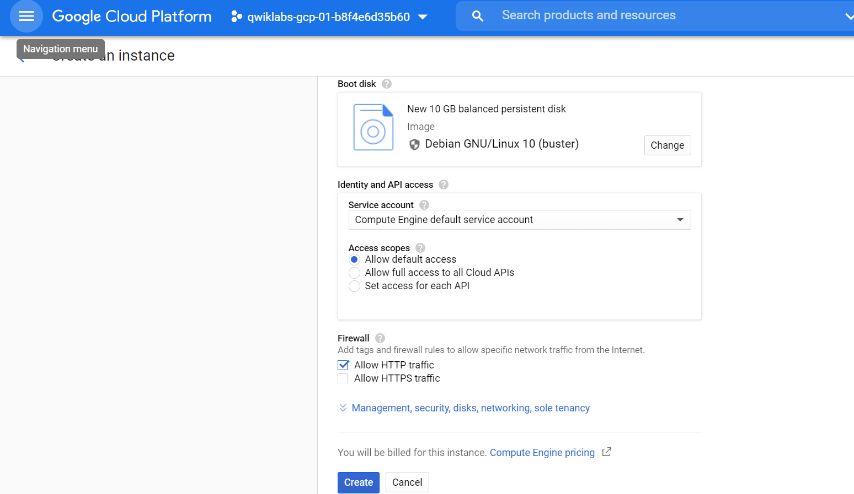

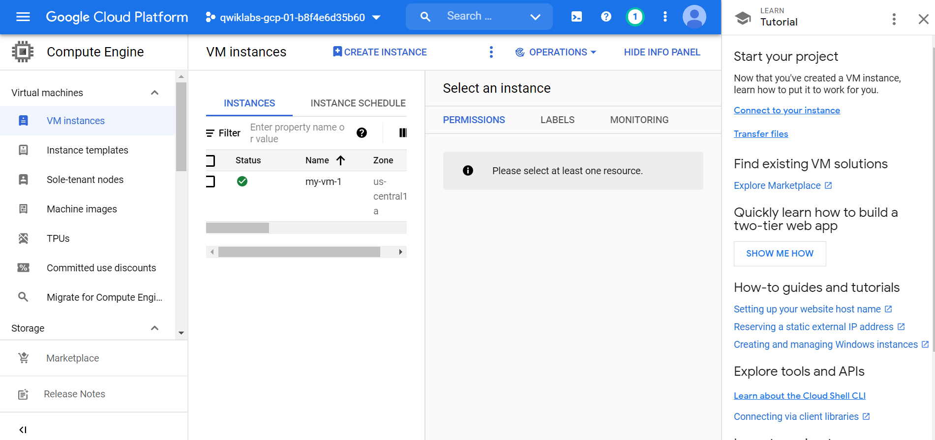

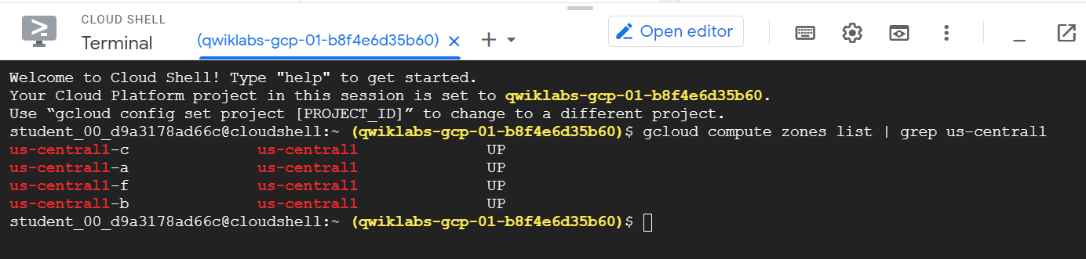

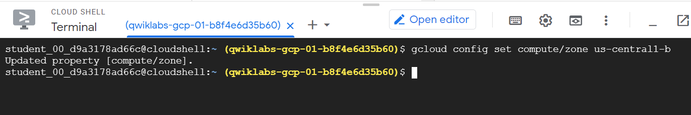

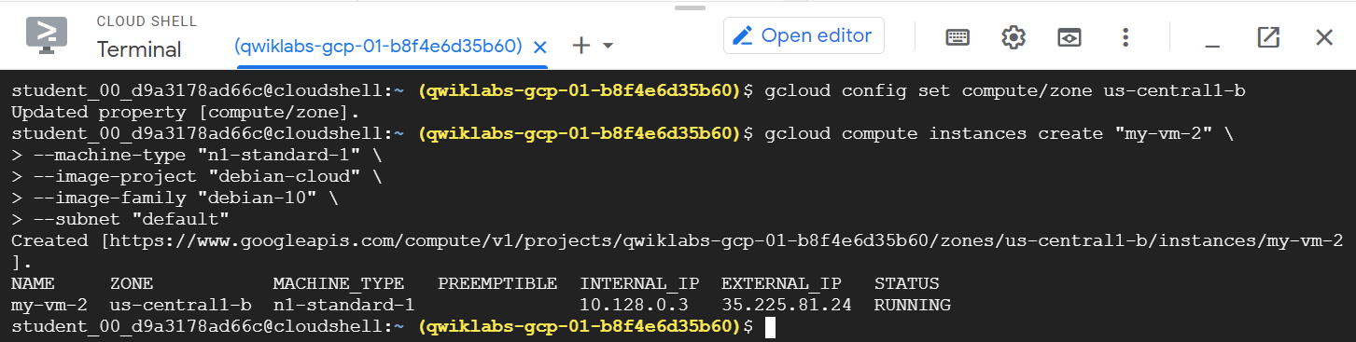

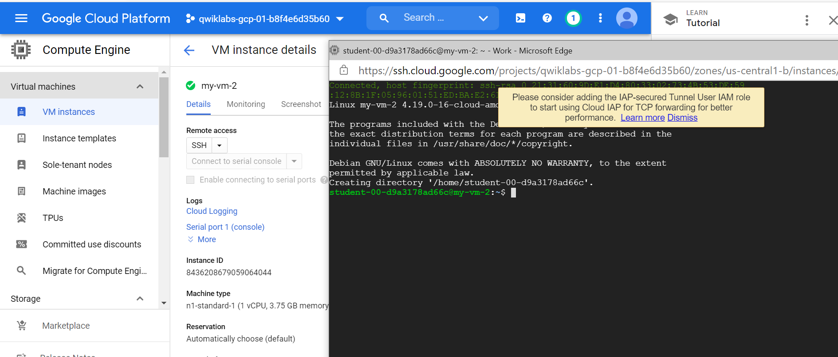

ping my-vm-1.us-central1-a

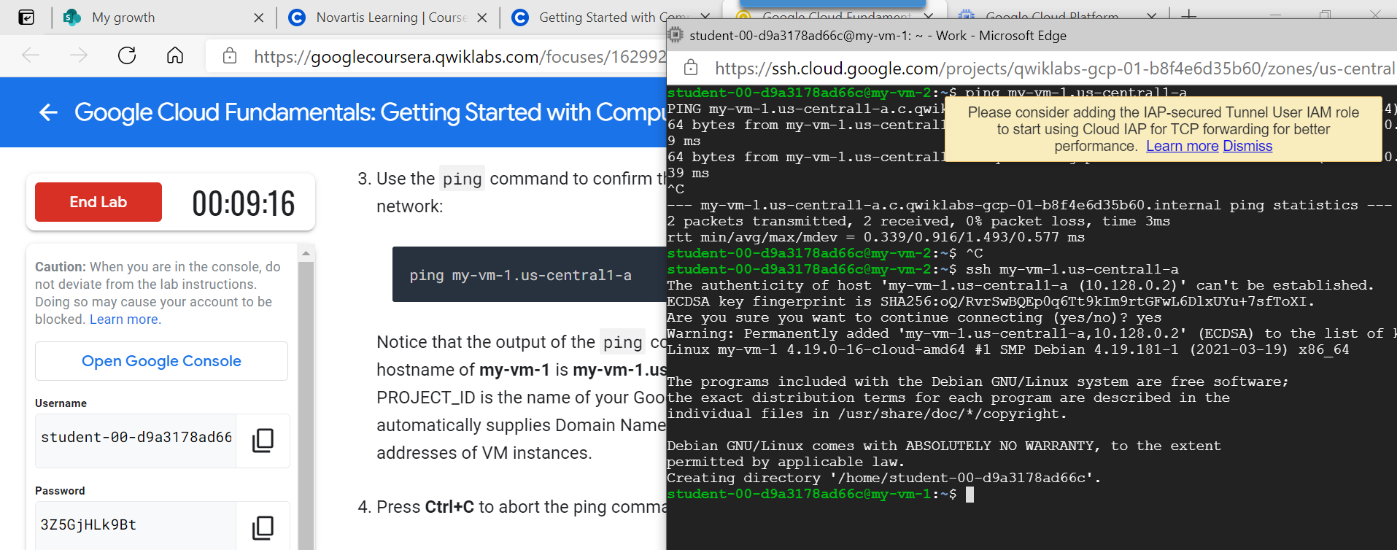

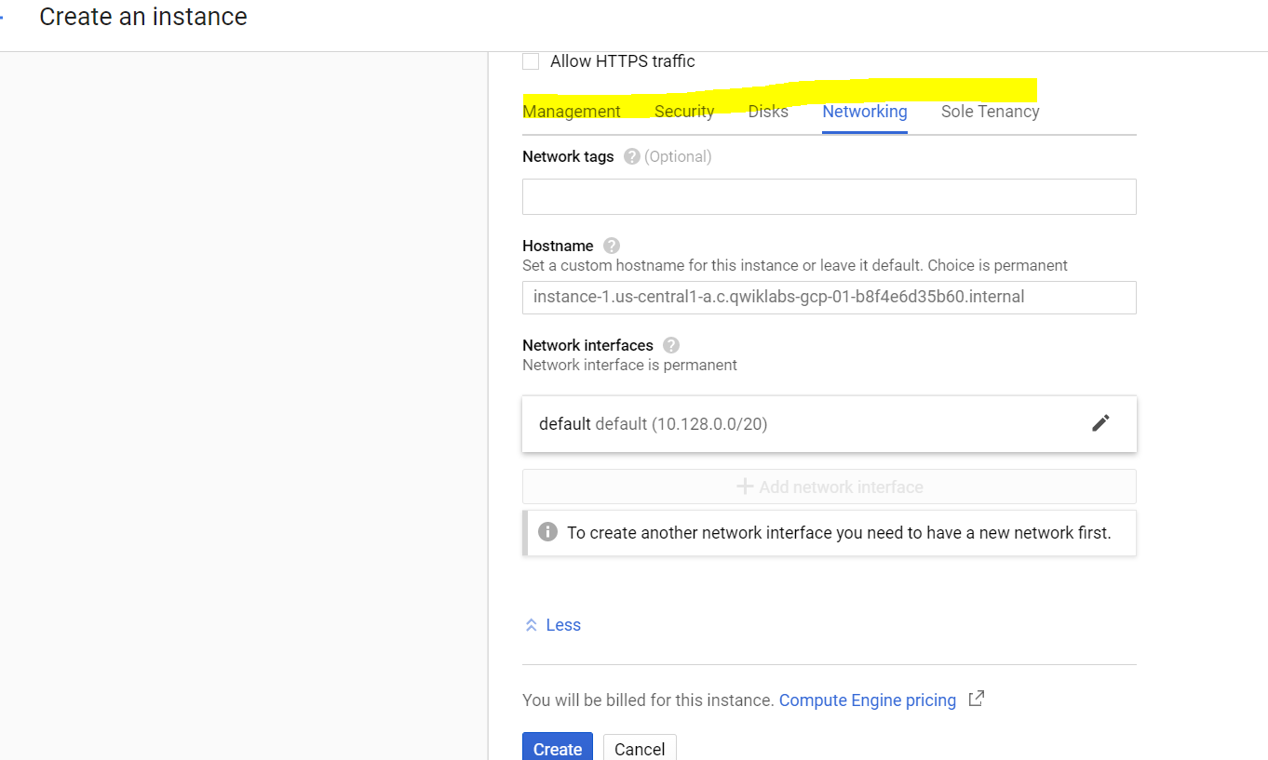

**Task 4: Connect between VM instances**

1. In the **Navigation menu** (), click **Compute Engine > VM instances**.

You will see the two VM instances you created, each in a different zone.

Notice that the Internal IP addresses of these two instances share the first three bytes in common. They reside on the same subnet in their Google Cloud VPC even though they are in different zones.

1. To open a command prompt on the **my-vm-2** instance, click **SSH** in its row in the **VM instances** list.
2. Use the ping command to confirm that **my-vm-2** can reach **my-vm-1** over the network:
3. ping my-vm-1.us-central1-a

content_copy

Notice that the output of the ping command reveals that the complete hostname of **my-vm-1** is **my-vm-1.us-central1-a.c.PROJECT_ID.internal**, where PROJECT_ID is the name of your Google Cloud Platform project. GCP automatically supplies Domain Name Service (DNS) resolution for the internal IP addresses of VM instances.

1. Press **Ctrl+C** to abort the ping command.
2. Use the **ssh** command to open a command prompt on **my-vm-1**:
3. ssh my-vm-1.us-central1-a

content_copy

If you are prompted about whether you want to continue connecting to a host with unknown authenticity, enter **yes** to confirm that you do.

1. At the command prompt on **my-vm-1**, install the Nginx web server:
2. sudo apt-get install nginx-light -y

content_copy

1. Use the **nano** text editor to add a custom message to the home page of the web server:
2. sudo nano /var/www/html/index.nginx-debian.html

content_copy

1. Use the arrow keys to move the cursor to the line just below the h1 header. Add text like this, and replace YOUR_NAME with your name:
2. Hi from YOUR_NAME

content_copy

1. Press **Ctrl+O** and then press **Enter** to save your edited file, and then press **Ctrl+X** to exit the nano text editor.
2. Confirm that the web server is serving your new page. At the command prompt on **my-vm-1**, execute this command:
3. curl http://localhost/

content_copy

The response will be the HTML source of the web server's home page, including your line of custom text.

1. To exit the command prompt on **my-vm-1**, execute this command:
2. exit

content_copy

You will return to the command prompt on **my-vm-2**

1. To confirm that **my-vm-2** can reach the web server on **my-vm-1**, at the command prompt on **my-vm-2**, execute this command:
2. curl http://my-vm-1.us-central1-a/

content_copy

The response will again be the HTML source of the web server's home page, including your line of custom text.

1. In the **Navigation menu** (), click **Compute Engine > VM instances**.
2. Copy the External IP address for **my-vm-1** and paste it into the address bar of a new browser tab. You will see your web server's home page, including your custom text.

If you forgot to click **Allow HTTP traffic** when you created the **my-vm-1** VM instance, your attempt to reach your web server's home page will fail. You can add a [firewall rule](https://cloud.google.com/vpc/docs/firewalls) to allow inbound traffic to your instances, although this topic is out of scope for this course.